**Government, liberal democracy, intro to law, and federalism, and what we’ve inherited from other nations.**

**(Intro)**

Government: The political and legal system of a nation state. The body that has legal authority to set a political party. In Australia, the government is the party that can maintain a majority in the lower house.

Forming government: Australian government is part of the Australian parliament. Federal election – the party or coalition of parties with the support of majority of members elected to the house of reps becomes the government. Although the government is formed in the house of reps, there are also members of government in the senate. The government doesn’t have to have majority of the seats in the senate.

Government Responsibilities:

* Develop new national policy.
* Introducing bills into parliament – new laws or changes to existing ones.
* Putting laws into action through departments.
* Making important decisions on behalf of Australians.
* Representing Australia overseas.

Rules within government:

Leader- prime minister – member of the House of Reps.

Ministers – Given areas of responsibility – a portfolio.

Backbencher – members of government – without portfolios.

Features of a good government:

* Democratic
* Representative
* Reflects backgrounds and needs of citizens.
* Participatory.
* Accountable.

Parliament: An assembly of elected representatives, usually having an upper house and a lower house which makes laws for the country.

Democracy: A political and legal system that is based on the principles of individual freedom and freedom and equality of the rule of the people.

**(Liberal democracy)**

Liberal Democracy: A system of government which is based on both popular sovereignty (will of the majority) and the respect and protection of our rights.

The 4 operating principles of a liberal democracy:

* Equality of political rights.
* Majority rule.
* Political participation.
* Political freedom.

Australian liberal democracy: It can be argued that Australia has both limited and protected key liberal democratic operating principles. Australia achieved:

* A representative democracy in 1901.
* Male suffrage in 1856.
* Female suffrage in 1902.
* Indigenous suffrage in 1962.

Nation states: Independent political unites that possess:

* A territory.
* A population.
* An organised political system.

**(Sovereignty within nation-states)**

Sovereignty within nation states: Sovereignty is the ‘authority to govern’. Nation states have the absolute right to govern within their territory and over their population without outside interference. Nation states cant interfere with the governing of other states and will defend the right to govern themselves.

International organisations and nation-states: Nation states can come together to form international organisations with each nation state having representation in the organisation. This does not override the sovereignty of the nation-state. The UN Is the most common example of a nation-state international organisation. Even the UN cant interfere with a states authority to govern itself.

Power of sovereignty within a nation state: Whoever exercises a nations sovereign power, is what determines whether a country is a democracy or not. In order to govern, nation-states must possess power. Power is the ability to direct, coerce, or influence others to act in a certain way. The source of a nation-states power is law. Law is the most effective exerting power because it controls peoples behaviour and is backed by the nation-states coercive force – police and court systems. Those who don't obey the law can be punished by the state. Law applies universally within a nation states territory, to the entire population (including visitors) and can be enforced by the state.

Governing institutions within nation-states: All nation states possess governing institutions that make, enforce, and interpret their laws. Nation states exercise power and govern through their governing institutions of a nation state make up its political and legal systems.

**(Law)**

Rule of law: a critical feature of a liberal democracy which is the principle by which everyone is subject to the law. All people, governments, cooperation’s and other entities are subject to law regardless of power, wealth, or any other quality. Law is the ultimate power in society.

Purpose of the rule of law: It protects citizens from abuses of power. In a liberal democracy, citizens can ultimately make their own laws through representatives. Through the rule of law citizens impose limits upon those in power.

Rule of law design features:

* Requires separate and independent courts.
* It would be against the principles of a liberal democracy if the judges and courts could be influenced by power or wealth to make decisions in court that favoured the government, powerful people, or companies.

The 4 characteristics of the rule of law:

* Universality of law.
* Law should be known, clear, consistent, and coherent.
* Methods of upholding the rule of law.
* Freedoms and equality before the law.

Universality of the law: The rule of law exists because of this, it means that nobody is above the law, even those who make law. This is the most well understood aspect of the law. Laws must be morally acceptable to the majority of citizens and reflect these moral truths.

Law should be known, clear, consistent, and coherent: People who are subject to the law should have an opportunity to know that a law exists before its applied. It is for this reason that laws are published after they are passed. Claiming that you did not know that a law exists in not an excuse. You can only be punished for disobeying a law after it is created, this is to prevent a person from being charged retrospectively for an act that was legal when it was being carried out. Consistency of application is also very important so that all adults are treated equally.

Methods for upholding the law: independence of courts is in democratic constitutions. Courts must be free of pressure and interference of governments, and must be able to adjucate governments matters purely on the basis of law. Judicial independence guarantees that judges cannot be pressured by governments or companies.

Freedoms and equality before the law: Rule of law exists when the law protects citizens equality, rights and freedoms. Rights and freedoms enable participation, which enables pressure on parliament and government. Legal rights such as the presumption of innocence and right to silence guards against arbitrary use of power. Courts protect these rights through trial processes and the common law. All people are treated equally before the law.

**(Doctrine of the separation of powers, checks and balances)**

Separation of powers: an essential part of liberal democracy, like rule of law. It ensures that the powers of government are organised in a way to prevent power being concentrated in one person or group. Power is separated or dispersed. If a society of citizens wishes to control the use of their governments powers, then it needs to split up the powers and spread them throughout the political and legal system because nobody should have too much power.

Role of government:

* Create laws.
* Administer laws.
* Apply laws.

Non-democratic system:

* In a non-democratic system, these roles are concentrated; however, in a liberal democracy, they’re separated.
* This separation provides accountability – a system of checks and balances on each other’s power.

Checks: a limit to someone's power.

Balances: an equivalence of two different types of power to ‘balance out’/ even out the other branches.

Where did the theory come from? French aristocrat Baron de Montesquieu.

* He noted that a key feature of Britain’s government was the dispersal of power as power to create law was held by a group or parliament, different to those who carried out law.
* Another group held the power to decide how the law applied to specific cases.

Legislative power: Makes and creates law. It may be called parliament, congress or assembly. It’s what makes Australia a representative democracy.

Executive power: PM, premier, governor general cabinet, public service are involved. Ministers responsible for portfolios. Public servants are involved.

Judicial power: resolves disputes, interprets law. The justice system contains judges and courts. Judges have judicial power, which is the power to make legally binding decisions. The courts are ranked in a hierarchy. You can only be dismissed for proved misbehaviour or incapacity. Judges are extremely secure in their role. They are free from interference or pressure from parliament.

Australia's checks and balances: Legislature, executive and judiciaries possess different power in relation to the law. Each one checks the power of all arms of government. Each has an internal structure and procedures for keeping itself accountable.

* Parliament – two houses check and balance each other. Each chamber has a presiding officer and rules they must follow.
* Executive – cabinet conventions (unwritten rules) keep ministers accountable.
* Judiciary – higher courts keep lower courts in the hierarchy accountable through the appeals process.

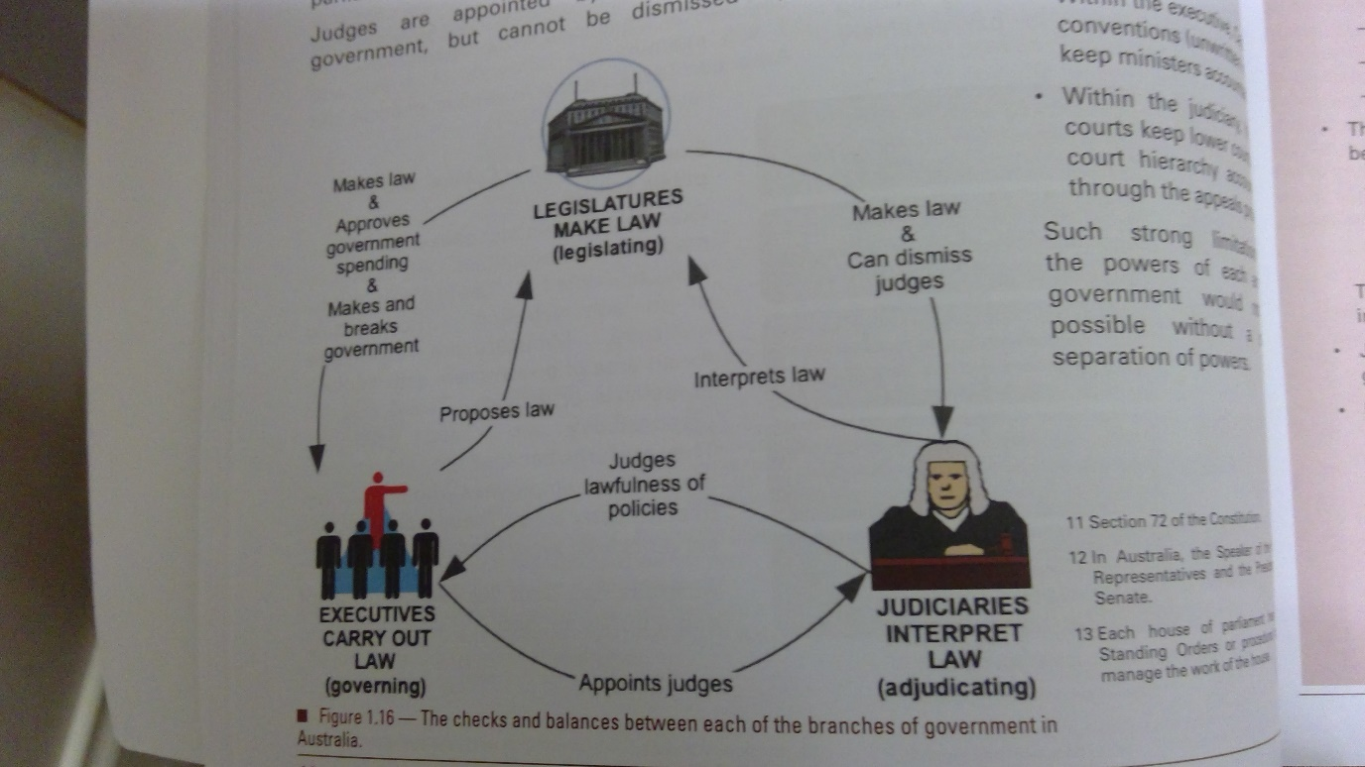

When has the separation of powers been useful in Australia? Section 44 controversy, which causes a constitutional crisis, as some members held a dual citizenship. The high court ruled that ministers with dual citizen ship could not run for election. MPs (executive) not following constitution, high court (judiciary) held them accountable.

When has the separation of powers been useful in the USA? During the covid 19 pandemic trump issued an executive order – state of emergency. This executive order can be overturned via judicial review to hold the president to account.

**(System of government)**

System of government: the political and legal system of a nation-state. Systems of government have 3 arms and take different gorms o=with distinguishing features.

Unitary system:

* A system of political organisation.
* Most or all of government power resides in a centralised government.
* UK or NZ are examples. They may have regional governments but their powers are granted to them by national government.

Federal system:

* A system of political organisation.
* They have national government and regional government called state governments.
* Their powers are guaranteed by the constitution and not granted by national government.
* There is a division of powers.
* Australia is an example.

Australia can be described as:

* Representative democracy.
* Constitutional monarchy.
* Federal democracy.
* Responsible parliamentary.

The crown: a formal part of parliament, the queen and her successors is the head of the state. However, she isn’t elected so she doesn’t have much power.

Bicameral parliament: A feature of all Australian parliaments (the federal and state). It means they have 2 houses of government. Its everywhere in Australia except queesnalnd, ACT and NT, who are unicameral.

House of reps, also known as peoples house:

* Members are elected by Australian citizens in the electorates in which they live.
* There is currently 151 electorates (in 2019).
* Geographical areas will approximately have the same number of voters.

Senate:

* Known as the states house.
* Primary role – to represent the interest of the states.
* Each original state is equally represented – 12 per state and 2 per territory.
* Elected by citizens in each state.
* They serve a 6 year term (commencing July 1st following election.)

Monarchy:

* One of the oldest and most common forms of government until recent times.
* Historically, most monarchies have been absolute kings/queen not limited by any law.
* This, however, is incompatible with the principles of a liberal democracy.

**(Federalism and how power is divided)**

Constitutionalism: This concept came out of the enlightenment period. The idea that government powers should be limited and not absolute. During this period that some monarchies evolved to a form that was subject to the law. Faced with the demands for increased democracy, some monarchies evolved from absolute monarchy into a from of monarchy that was subject to law which limited its power. Laws that limit their power are called constitutions.

Constitutional monarchy:

* Australia is a constitutional monarchy due to its historical ties with Britain.
* When Australia's political and legal system was being created, it was decided the British monarch would also be Australia’s.
* Australia's constitution establishes the role of the governor general.
* Monarch is granted executive power in the Australian constitution.
* Federal executive council established to advice the governor general.

Governor general: a governor general, representing the crown exercises the roles and powers of the monarch in Australia.

Federal executive council: A council of ministers. EXCO is another institution of the constitutional monarchy in Australia. When people talk about government, they are generally talking about the executive arm of government. The head of government is the PM, who determines policy and administration of government.

Responsible government: used in the context of the British phrase ‘responsible parliamentary government.’ Responsible means that the executive is directly drawn from and accountable to the parliament. In a responsible parliamentary system, parliaments aksi have a role of questioning and scrutinising the government each sitting via:

* Question time.
* Parliamentary committees.

Examines aspects of the executive’s performance and spending.

Responsibility in government:

* Individual ministerial responsibility (IMR)
* Collective ministerial responsibility (CMR)

Individual ministerial responsibility: Parliament uses its own procedures to hold individual ministers to account for their performance during things like question time, debate, committees. Parliament can also hold individual ministers to account for their personal conduct. If a minister is personally or politically corrupt, the parliament may hold them accountable through a censure motion.

Collective ministerial responsibility: Parliament may hold the entire government accountable for its operations. If a government is incompetent or corrupt, the parliament may hold them accountable via motion of no confidence. An essential element of a responsible parliamentary government is that government must maintain the confidence of the lower house.

Responsible government: A final element of a responsible government relates to appropriation. The government is unable to spend money in Australia unless it has been approved by parliament through the normal passage of a bill. Governments require money for the administration of laws to carry out their policies.

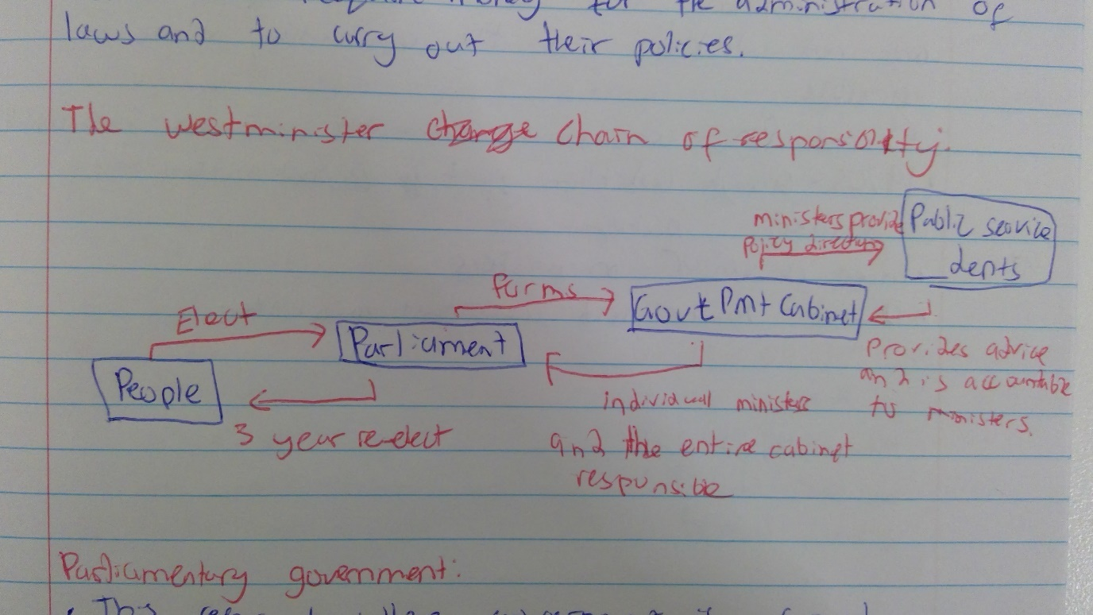Parliamentary government: This refers to where government is formed. In Australia its formed in the legislative branch. Fusion is between legislative and executive branches. Government is formed in the house of Reps.

Cabinet: Important component of a responsible parliamentary government. Emerged as a way of limiting power of the monarch. The cabinet is a committee of executive comprising the PM and their senior ministers. The cabinet is governed entirely by a convention and has no legal or constitutional authority. Despite this, its still the most powerful institution in the Westminster system.

Cabinet system: Since the operators of the cabinet are not written in the constitution it can be flexible. Some PMs are more authoritative some are more consultive. There is inner and senior ministries.

Australian federalism: late 1800s, Australia was looking to write the colonies as one nation. They needed a system of government that would still allow power to the states/colonies.

Federalism: A system of government in which sovereignty is geographically divided between one central government and 2 or more regional governments. It’s the opposite of a unitary government. The USA and Canada are also federal systems.

At both levels there is a separation of powers:

* 6 Governors
* 6 state executive governments
* 6 states court systems
* 6 state parliaments.

Federal power can look like:

1. Coercive federalism – national government is more powerful than regional.
2. Dual/cooperative federalism – both levels have about the same amount of power.
3. Confederation – regional governments have more power than the national government

* Balance is not fixed
* High court decisions/referendums/referral of powers can change balance.

Constitution allocates power between the levels: It’s called division of powers.

1. Exclusive powers
2. Concurrent powers
3. Residual powers

Exclusive: Powers are granted to the commonwealth parliament by the constitution – these areas can only be legislated on by the commonwealth. These are matters that are national in nature. Section 52 of parliament has exclusive power to make laws for the peace, order, good government and the commonwealth public service.

Concurrent: power granted by the constitution the commonwealth and state parliaments, which means shared powers. These are listed in section 51

Eg:

S.51 (i) – trade and commerce.

S.51 (ii) – taxation.

S.51 (ix) – quarantine.

S.51 (xxi) – Marriage.

If there is ever inconsistencies, s.109 states that the commonwealth law will prevail.

Residual: All government powers not specified/enumerated in the constitution – these are excersised by the states. Residual powers relate to the matters that are regional in nature such as:

* Education.
* Health.
* Roads and railways.
* Criminal and civil law.

Chapter 5 of the constitution preserves the states constitutions powers and laws.

**(Federation and Australia's blended constitution)**

Colonisation: Settled by British in 1788. Esablished as a penal colony. 1788-1868 – approximately 100,000 convicts transported to Australia.

Self-government: A grant of internal anatomy over most matters of the colony. Meant they could create law wand carry it out independently to the UK.

Why federate?

* Defence
* Fear of Asian immigration
* Trade
* Australian identity

Federation: Political leaders across Australia believed that a political union that brought them together would address the issues of defence, economic integration and identity.

Key influences: Although the founding fathers knew that a new Australia would use many of the British west-minister features, they also knew that it alone would not work, and that’s why they incorporated features from the USA, Canada, and Switzerland.

**(The US Federal system)**

US system:

* Federalism.
* Founding fathers divided sovereignty geographically.
* 1 National (federal) government.
* Converted Colonies into states – regional governments.

Allocation of powers:

* Division of power between states and national governments.
* Constitution allocated powers to each level of government.
* Specified executive and concurrent powers of constitution.
* Residual not specified like Australia.

Written constitution:

* Very similar to Australia
* USA and Australian constitution took effect when states unified.
* Details the elements and processes of 3 branches – legislative, executive and judicial.
* Australia – executive drawn from legislature.

The 3 branches: The federal government has 3 branches:

1. Legislative: House of Representatives/ senate.
2. Executive: President, cabinet, federal departments, agencies.
3. Judicial: Supreme court, other federal courts.

Congress:

* Legislative branch.
* Their union of parliament.
* House of representatives – lower chamber, which is made up of elected represented reps.
* Senate – upper chamber – represents each state (each state has two senators.)

Court:

* USA – supreme court justices nominated by president confirmed by senate.
* Australia – governor general appoints high court Justices.
* USA has supreme court.
* Australia has high court.
* Both – Hierarchy of lower courts beneath.
* Both – interpret constitution.
* US – each state has a supreme court.